## 



Smart mobile

Design document

**Desislava Petrova**

**Ivan Ivanov**

**Imran Al Touqi**

# Desislava Petrova -

# Desislava Petrova -

# Desislava Petrova -

**Description**

BeFit is a fitness challenge app that can be download on Android devices. It will track your food, drinks and activities. With the app you can monitor your progress. Every day you will have a challenge depending on your final goal. In order to keep you from choking and losing motivation, you can add your friends and challenge them.

**Goal**

Our goal is to stimulate people to train and to to turn their trainings into a routine.

**Survey**

32 people took part in the survey.

Q1. How old are you?

Q2. Have you ever used a fitness app?

34%

Q3. If “yes”, for how long you used the app?

46%

Q4. If "no", what would make you use a fitness app?

Most popular answers:

* Information from people that actually know what they are talking about.
* More information about the foods
* Interactive interface

Q5. If you ever used such an application, why did you stop?

Most popular answers:

* I lost my motivation
* Boring
* Because I use YouTube and I find it easier

Q6. What do you think would keep your motivation to use the fitness app?

Most popular answers:

* If the app works well and keeps things interesting while you exercise
* I would use it to boost my motivation and track my progress.
* Maybe doing something with my friends, tracking my friends progress
* Useful and easy to use
* Challenges of any type, levels of improvement for example
* Some type of achievement system
* Maybe training in groups or with friends

Q7. Do you think that if you train with your friends, you will be more motivated?

94%

Q8. How about challenging your friends in the app?

63%

<https://goo.gl/forms/VW2LNkaqu1t86qOJ3>

**Hardware**

* GPS
* Internet
* Camera

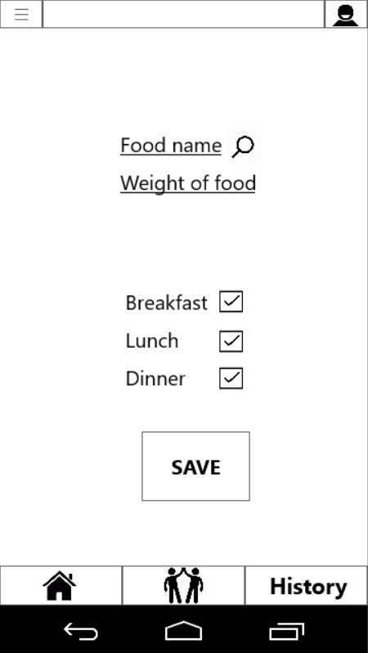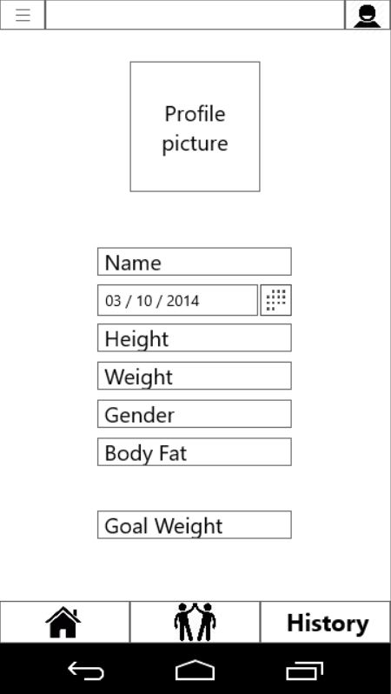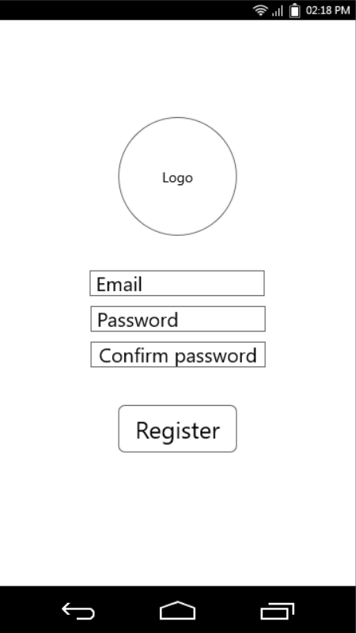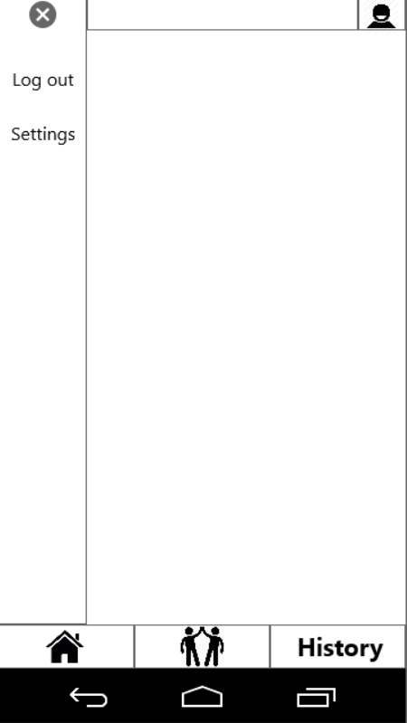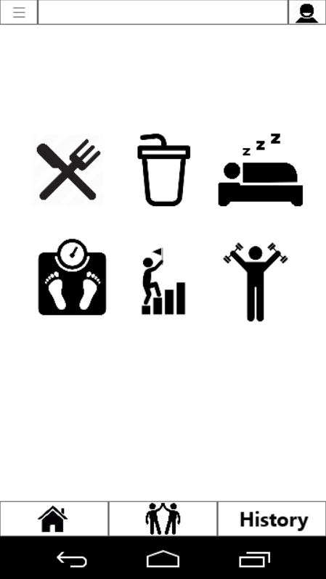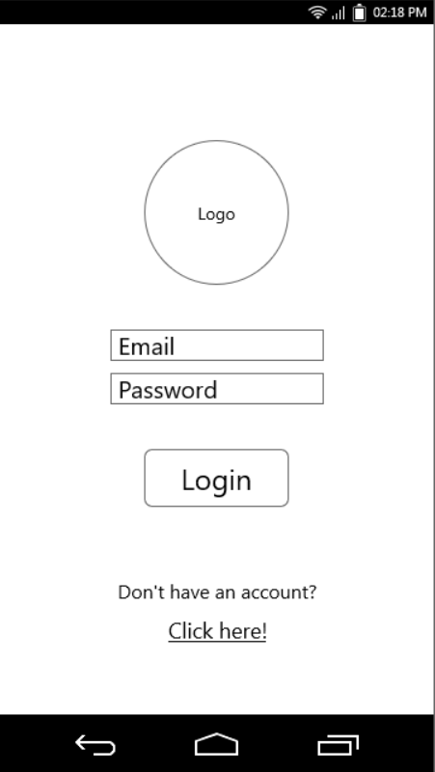**Wireframe**

**Wireframe**

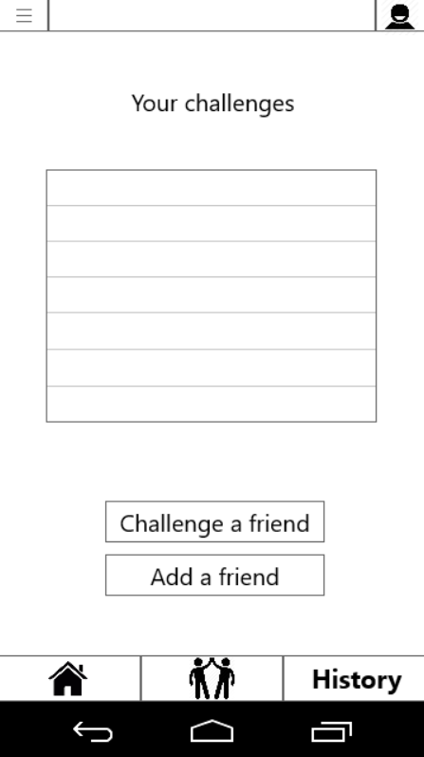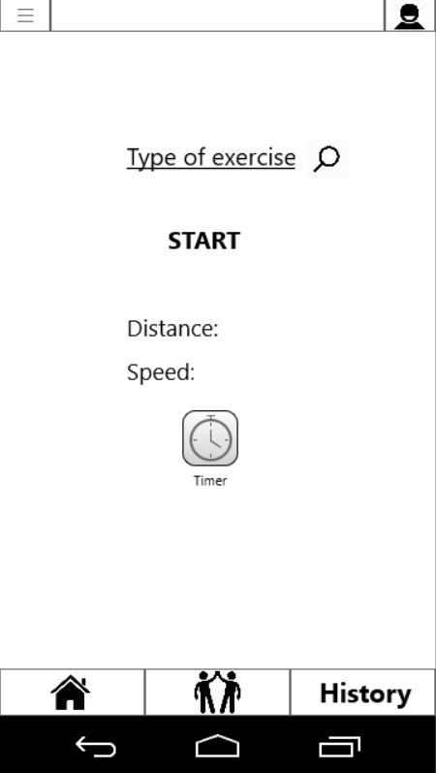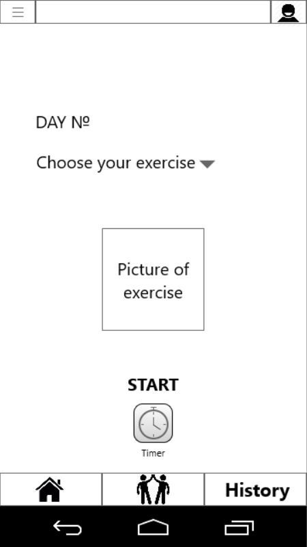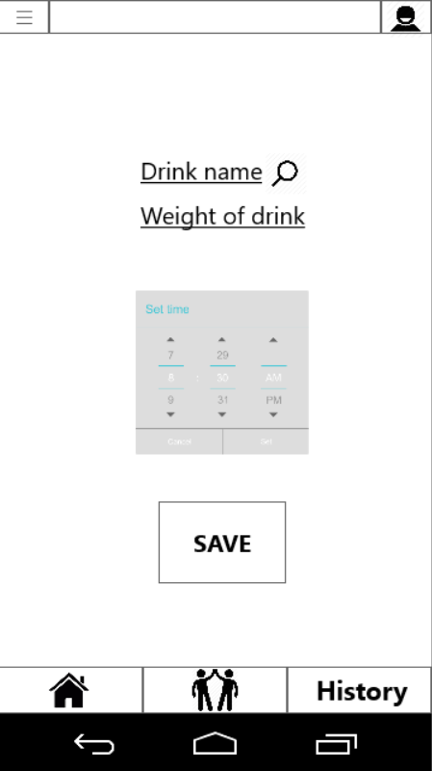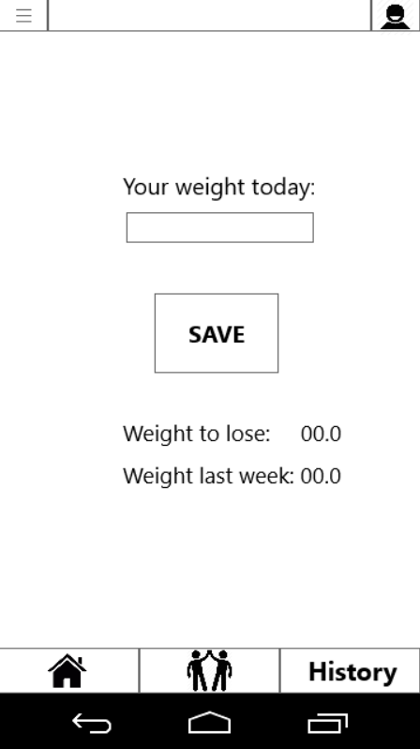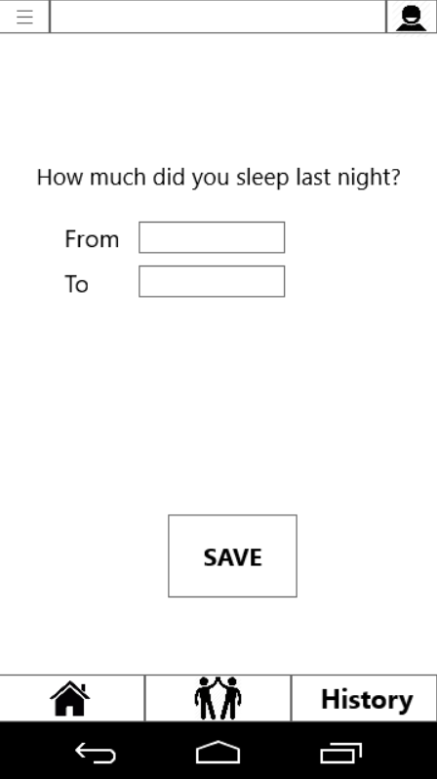

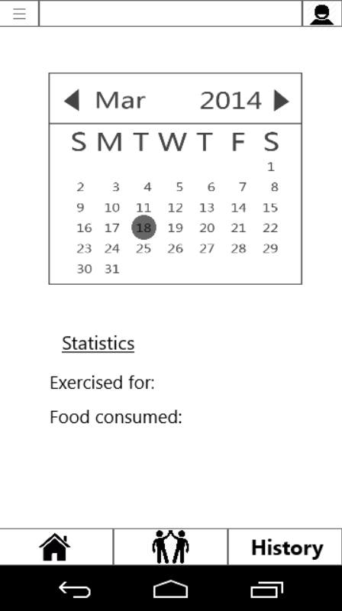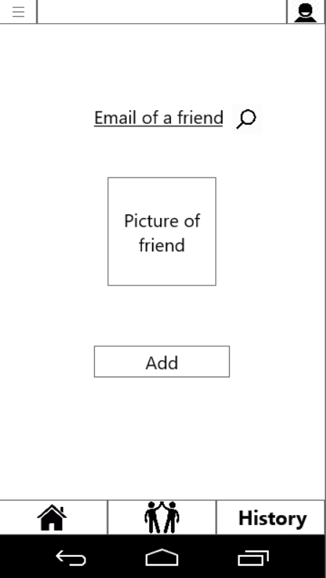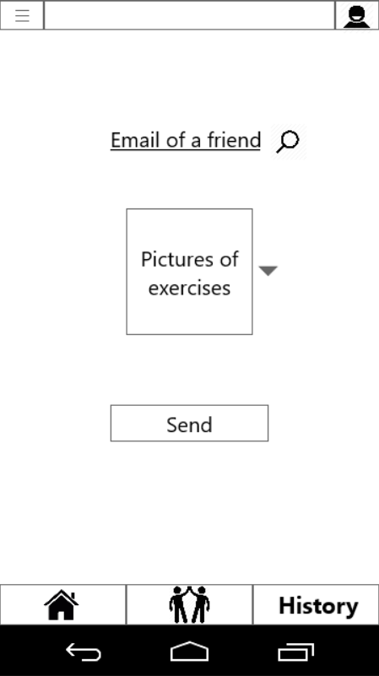

**Story boards**

Story board 1:

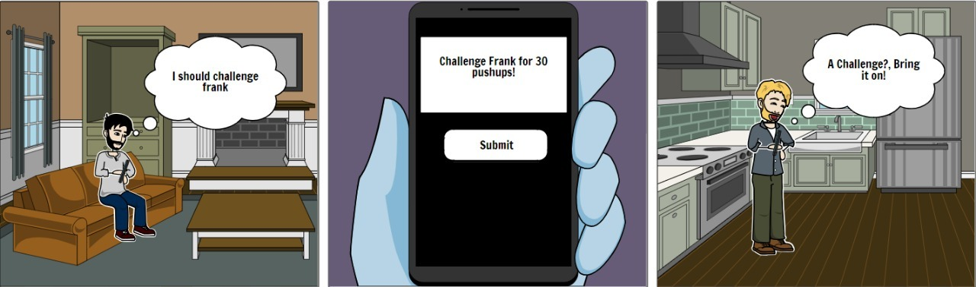

Story board 3:

Story board 2:

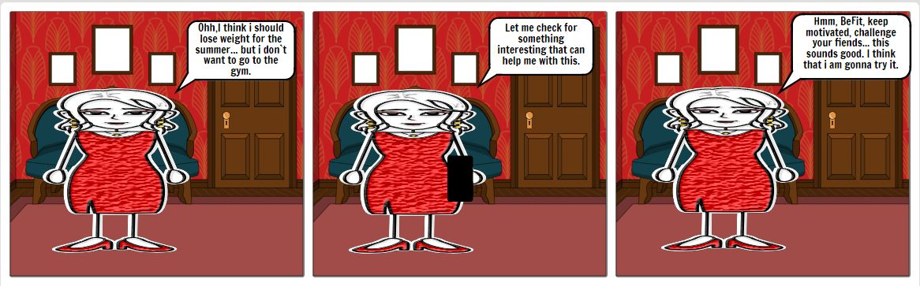

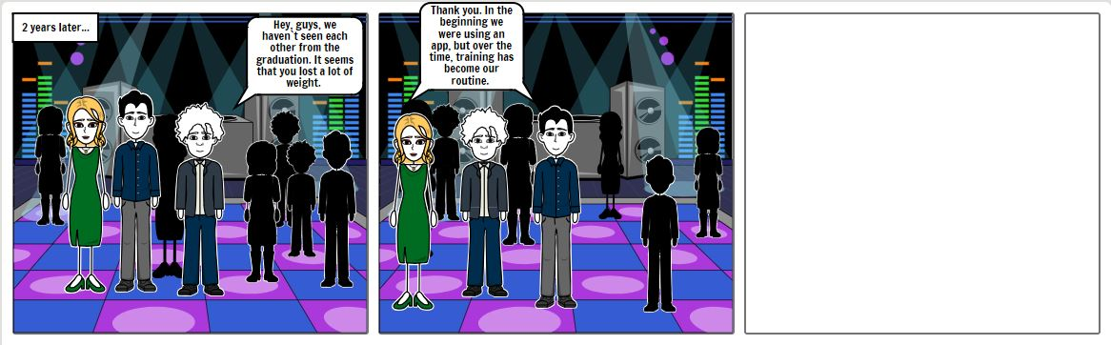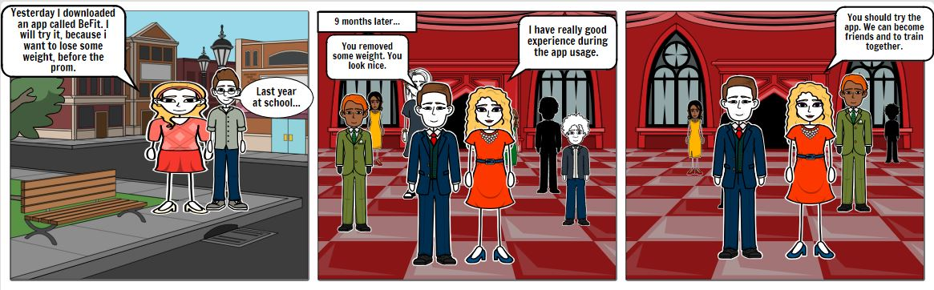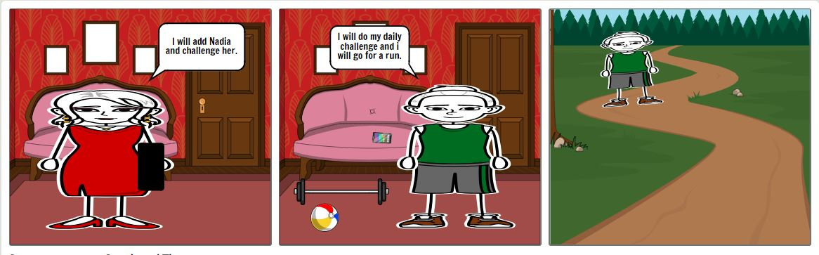

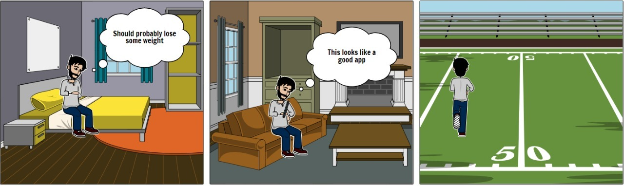

Story board 4:

**Personas**

 Meet Dirk

**Age:** 28

**Relationship status:** Single

**Profession:** Software Developer

**Background:** Dirk has been on the heavy side all his life and wants to finally lose some weight and get in shape for the summer

**Interests:** Video games, watching movies, listening to music

**Characteristics:** Friendly, good-humored, helpful



Meet Sarah

**Age:** 25

**Relationship status:** Has a fiancé

**Profession:** Teacher

**Background:** Sarah has just been proposed to and has 5 months to slim down for her wedding. She also wants to make this a lifestyle and be healthier

**Interests:** Arts, dancing, theatre, Netflix

**Characteristics:** Sociable, helpful, friendly, approachable

**From where we got the idea for the app?**

1. **Tiny Habits - article**

One of the first articles/websites we found online was Tiny Habits by BJ Fogg. His details and information can be found on his website - https://www.tinyhabits.com/. His whole course is not free, however, he has given an outline for success. According to him, there are 3 options to change your behavior in the long term. They are – Having an epiphany, changing your environment or taking baby steps. The first option is obviously very hard to do, so he has focused on the other 2 steps, which are more feasible to do in the long run. Not only that, but based on our past experiences with weight loss, we know for certain that just waking up one day and changing your whole diet and outlook on life is extremely difficult in normal circumstances. So we have decided to focus on taking baby steps. Trying to make this whole weight loss thing a lifestyle, so that after people achieve their goal weight a few months down the road, they continue with living a healthy lifestyle, exercising regularly and having a more positive outlook on life.

**Reference list:**

* Fogg, B. ( DATE) “Tiny Habits” , Retrieved February 28 2019, from <https://www.tinyhabits.com/?fbclid=IwAR2Gnecz9fY3t2N1s02FqddF6zFjqB3rx_Xp_AXVL1hddnh13A0HjKMJwBQ>

1. **Ivan - group member**

Our experience with losing weight has been very hard in the past. We have struggled with many fad diets which are not only difficult but actually unhealthy. There are some extreme methods online that people follow without thinking because they are promised infeasible results. For example, drinking cleansing juices all day, eating 500 calories every day. These diets are not only unsustainable for the long term but also unhealthy. That is why we have decided to come up with an application that will guide people in losing weight by mainly tracking calories.

1. **How to stay motivated at the gym - article**

We found this article interesting and helpful, because everyone of use used to train at some point in our lives and according to our experience, we know that it is boring to train alone.   
From another point of view, everyone knows that people are more stimulated to do something when there is some challenges or something to achieve. Everyone is familiar what happens when two friends compete.

**Reference list:**

* Macha, A.,(April 6, 2017), “6 secrets to staying motivated at the gym” , Retrieved March 03 2019, from <https://www.nbcnews.com/better/pop-culture/how-motivate-yourself-get-out-bed-work-out-today-ncna743006>

**Design/ Prototype**

**Link:** <https://www.youtube.com/watch?v=zgwexUoS1os&feature=youtu.be&fbclid=IwAR3x-TdkK1rV0_bBJQozo3bMGnlXPtceAofc-7Mxs4S3wdZe7aLgCpnuOGM>